Problem Statement
Project Management Offices (PMOs) struggle to effectively deliver strategic value due to fragmented data (across multiple systems, formats and teams), manual processes, and limited predictive capabilities. Here are some of a PMOs persistent challenges:

Core issues
- Lack of real time visibility
  - Data is spread across multiple systems (JIRA, SharePoint, Teams etc.)-There is no single place that shows the full project picture.
  - Reporting Lag (Time Delays)- Sometimes by the time leadership see reports they may already be outdated.
  - Manual Data Entry & Updates- can be delayed if some teams don’t update on time so data may be inconsistent and not truly real time.
  - Lack of System Integration- Data that has to be copied from one system to another can cause inconsistencies as changes in one system don’t automatically reflect in others.
  - Communication gaps- No centralised communication trail means some information may get lost.
- Manual and time-consuming reporting
  - Lack of automation- Data has to be exported from one system and combined manually.
    - Reports in PowerPoint/ excel have to be updated manually for each reporting cycle- there is no live linkage to underlying data.
  - Customisation for Different Audiences – Multiple versions of the same report are created manually for executives, stakeholders and project teams etc.
- RAID Logs- Poor risk identification and forecasting
  - No consolidated view of project health - Risks are not visible holistically, so early warning signs are missed.
  - Real time risk issues- Risk assessments are based on periodic reports so any issues that arise between reporting cycles may be missed or identified too late
  - No continuous monitoring of risks - Risks are identified only when they become visible problems
  - Reliance on basic reporting (status = red/amber/green) - No predictive models or advanced analytics and no automated alerts advising a risk is slipping into a red status.
- Inefficient resource management
- Inconsistent governance
Governance standards are applied unevenly across projects and teams, with quality largely dependent on who is conducting the review and when. Without automated, continuous checks against a defined framework, projects can progress through delivery with gaps that go unnoticed until they create downstream risk.
- Knowledge Loss
When PMs leave or rotate, institutional knowledge about risks, decisions, and context often disappears with them. AI systems could prevent this.

Potential AI Solutions
PMO AI Agent - Can turn raw meeting minutes, status updates, and project data into structured, stakeholder-ready reports.
Upload your meeting notes in any format and the agent automatically extracts every action, decision, risk, issue, and dependency - flagging gaps, detecting conflicts with previous records, and updating your project register without manual effort.
From there, generate the right report for the right audience. Executives receive a concise half-page summary. Steering groups get a full programme health report with RAG status, escalations, and financials. Project teams get their action lists.
Built on PMO best practice, the agent applies consistent RAG thresholds across your portfolio, automatically escalates deteriorating projects, and ensures nothing falls through the cracks between meetings.
Key capabilities:
- Ingest minutes from documents, transcripts, emails, or raw notes
- Extract and structure actions, decisions, RAID log items, and dependencies
- Generate reports tailored to all audience levels — Board to individual
- Track project health trends and trigger escalation alerts automatically
- Configurable to organisation's projects, reporting cycle, and governance structure
How it could work
Orchestrated AI agents turning raw inputs into polished, audience-specific outputs
A central orchestrator agent receives unstructured inputs:
- Meeting transcripts
- RAID logs
- Project plans
- Status Emails
- Routes them to specialist sub-agents
What are Sub Agents
Sub-agents are focused AI components designed for specific tasks or audiences. They can be programmed using clear system instructions and connected data sources to consistently produce structured outputs, such as reports or updates, in the required format and tone.
The PMO will be responsible for maintaining up to date inputs and validating outputs to stakeholders, ensuring both control and quality assurance.

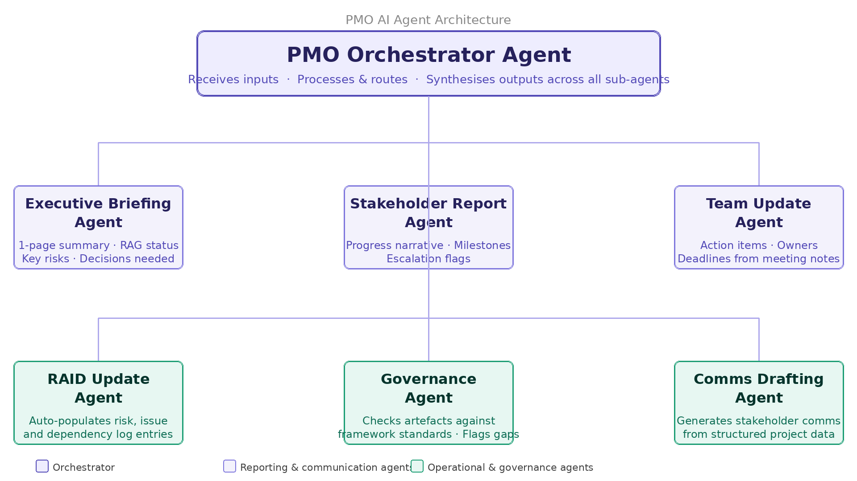

Executive Briefing Agent
Transforms project data into concise, standardised executive summaries covering project health, RAG status, key risks, and required decisions.
Eliminates manual effort while ensuring leadership receives consistent, high-quality insights without overload or loss of confidence.

Stakeholder Report Agent
Generates detailed but digestible reports for sponsors and senior stakeholders, including progress against milestones, budget variance, dependencies, and escalations.
Removes duplication by producing tailored reports from a single data source, reducing PMO reporting overhead.

Team Update Agent
Converts meeting inputs into clear team-level updates with actions, owners, deadlines, decisions, and blockers.
Improves accountability and reduces project drift by ensuring clarity on next steps after every interaction.

RAID Update Agent
Automatically captures and maintains risks, assumptions, issues, and dependencies from project inputs, while flagging stale items for review.
Creates a continuously updated RAID log, reducing missed risks and outdated reporting.

Governance Agent
Continuously assesses projects against governance standards, checking documentation, approvals and criteria.
Provides consistent oversight via scorecards and actionable remediation, replacing inconsistent manual audits.

Comms Drafting Agent
Produces ready-to-send stakeholder communications (e.g. escalations, updates, milestones) in the appropriate tone.
Reduces time spent drafting while improving consistency, timeliness, and professionalism of communications.

Actions
- Nikolas / Gavin to set up Jira board and scope requirements
- Dearbhla to assist Sarah with documentation for funding from invest NI
- Leah to set up project on Delivery Central
- Competitor Market Research – What do their services look like?
- Market Research to be completed by interview/survey of existing PMOs
  - Nikolas to speak to PMOs from MUFG, Bank Of America, BOC, BOI
  - Gavin - Citi Bank
  - Olivia – AIB
  - Ana – Mizuho
  - Leah – Natwest
  - Dearbhla – Northern Trust

Next Steps
- Draft example reports and formatting that can be used to train agents
- What do existing AI systems do well / poorly – what can we replicate / improve specifically for PMO
- Templates – Scorecard, RAID Log, Meeting minutes
- Set up sessions with existing PMO AAS from each client to gain insights on what a potential AI solution could be and how they would use it
- Project Planning
- Task Tracking / Action Log
- Flagging upcoming milestones
- MSP/Jira Updates into a Scorecard

Draft Jira Actions
Requirements
Research
Meetings / Microsoft Form with PMOs on client site to determine:
Biggest blockers
What tools are they using / what is working well
What could our tool do that isn’t being done currently
Draft questions
Product
Build an example - which agent to implement first?

Create example documents for AI training
Example inputs
Example outputs

Go to market
How would PMOs add more value with more time post AI tool implementation

Admin
Define how actions and decisions will be tracked
Build board for Jira

